Analysis Report Document

Stats4SD

29 July, 2019

You are reading a report generated by ClimMob. This is a software package to analyze data generated by citizen science or crowdsourcing.

# Introduction

In agriculture, the local environmental conditions determine to a large degree which technological solutions are the most suitable. In dry soils, for example, drought-resistant crop varieties will outperform other varieties, but in wet soils these same varieties may do worse than most. Not only drought, but an entire range of problems including excessive heat, floods, new pests and diseases tend to intensify under climate change. This multitude of limiting factors requires multiple technological solutions, tested in diverse environments.

Citizen science is based on the cooperation of citizen scientist or observers (paid or unpaid). Researchers assign microtasks (observations, experiments…) that, once completed and gathered, contribute with a great amount of information to science. One of the advantages of citizen science is that agricultural researchers can get access to many environments by crowdsourcing their experiments. As farmers contribute with their time, skills and knowledge to the investigation, researchers are able to do more tests than in a traditional setup. Also citizen scientists acquire new knowledge, abilities and information useful for future challenges of their work.

**ClimMob**

The primary goal of ClimMob is to help farmers adapt to variable and changing climates. ClimMob was created as part of Bioversity International’s research in the CGIAR Research Programme on Climate Change, Agriculture, and Food Security (CCAFS). It serves to prepare and analyze citizen science experiments in which a large number of farmers observe and compare different technological options under a wide range environmental conditions (van Etten 2011).

ClimMob software assigns a limited number of items (typically 3 crop varieties or agricultural practices) to each farmer, who will compare their performance. Each farmer gets a different combination of items drawn from a much larger set of items. Comparisons of this kind are thought to be a very reliable way to obtain data from human observers (Martin 2004). Once the results of the microtasks have been collected, ClimMob builds an image of the whole set of assigned objects, combining all observations. ClimMob not only reconstructs the overall ordering of items, but also takes into account differences and similarities between observers and the conditions under which they observe. It assigns similar observers to groups that each corresponds to a different preference profile. Groups are created on the basis of variables such as the characteristics of the plot, geography, age, gender…

ClimMob uses a recently published statistical method to analyze ranking data (Strobl et al. 2011). It automatically generates analytical reports, as well as individualized information sheets for each participant. ClimMob will hopefully help many agricultural researchers to start using crowdsourcing approaches in order to accelerate climate change adaptation.

Complementary to the microtaks performed by the farmers, a detailed environmental monitoring is performed, using new, cheap sensors (Mittra et al. 2013), makes it possible to compare across sites and predict crop variety performance for new places.

**How to cite**

If you publish any results generated with ClimMob, you should cite a number of articles as the package builds on various contributions. Van Etten (2011) introduced the crowdsourcing philosophy behind ClimMob. It is important to mention that ClimMob is implemented in R, a free, open-source analysis software (R Development Core Team 2012). Methodologically, if you report on the tree results, you should mentioned that ClimMob applies the Bradley-Terry tree method published by Strobl et al. (2011). To cite ClimMob itself, mention Van Etten & Calderer (2015).

# Section 1: Headline Results

## Overall Differences in Rankings

Overall there were statistically significant differences found in the rankings of varietys in the overall ranking (p=< 2.22e-16 ***). The best ranked varietys overall were K9107, CSW18 . Statistically significant differences were also found in the trait(s) germination, grainquality, yield

A summary of the p-values testing the hypothesis that there exist differences in the rankings within each of the Plackett-Luce models fitted for each of the assessed traits, and the list of varietys which were significantly highest and lowest ranked overall, are summarised in Table 1.1.

Table 1.1: Summary of Differences Found In varietys by Trait

|  |  |  |  |
| --- | --- | --- | --- |
| Ranking | p.value | Best Ranked | Worst Ranked |
| Overall | < 2.22e-16 *** | K9107, CSW18 | K0307, HI1563, HP1633, HW2045, HD2824, WR544, RAJ4120, PBW550, PBW502 |
| germination | < 2.22e-16 *** | CSW18, K9107, PBW343 | HW2045, HD2824, HP1633, HI1563, PBW550, RAJ4120, WR544 |
| grainquality | < 2.22e-16 *** | CSW18, K9107, PBW343 | HW2045, HD2824, HP1633, HI1563, RAJ4120, PBW550, PBW502, WR544 |
| yield | < 2.22e-16 *** | CSW18, K9107, PBW343 | HW2045, HI1563, HD2824, HP1633, RAJ4120, WR544, PBW550, PBW502 |

See Section 3 for further details.

## Effect of covariates

2 of the variables tested were found to have a statistically significant relationship to the overall ranking. These variable(s) were: lon (p=1.8724e-06), lat (p=7.1691e-09)

A summary of the univariate signifance levels for all covariates that were able to be tested is shown in Table 1.2.1.

Table 1.2.1: Summary of univariate p-values for first split in Plackett-Luce tree model for the overall ranking

|  |  |
| --- | --- |
| Variable | p |
| age | 0.98247 |
| gender | 0.99846 |
| planting_date | 0.70342 |
| lon | 1.8724e-06 *** |
| lat | 7.1691e-09 *** |

The variable(s) village, district were not able to be included within the analysis.

Table 1.2.2 summarises the different subgroups identified in the overall rankings from a multivariate analysis considering all possible covariates. This summarises the subgroup definitions and the varietys identified as the best and worst performers within that subgroup.

Table 1.2.2: Summary of different subgroups identified by multivariate Plackett-Luce tree model

|  |  |  |  |
| --- | --- | --- | --- |
| Subgroup | Number of Respondents | Best Ranked Varieties | Worst Ranked Varieties |
| lat <= 25.705 | 70 | DPW621-50, K9107, CSW18 | K0307, PBW502, WR544 |
| lat > 25.705 | 423 | K9107, PBW343, CSW18 | HI1563, HW2045, HP1633, HD2824, RAJ4120, PBW550 |

See Section 4 for further details.

## Relationships between traits

Table 1.3 shows the frequency with which the ranking of each of the different traits included within the study matched with the ranking within the ranking of the varietys considering their overall impression of the variety.

The trait which had the strongest relationship with the overall ranking was yield. Overall the rankings for yield matched the rankings for the overall ranking 81.3% of the time.

The trait which had the weakest relationship with the overall ranking was germination. Overall the rankings for germination matched the rankings for the overall ranking only 73.8% of the time.

Table 1.3: Relationship between individual trait assessment and overall assesment

|  |  |
| --- | --- |
| trait | Overall % Agreement |
| germination | 74% |
| grainquality | 78% |
| yield | 81% |

See Section 5 for further details.

# Section 2: Data Summary & Exploratory Analysis

## Summary of data collected

Table 2.1 provides a summary of the varietys assessed within this trial, with the frequency and percentage of farmers who assessed each variety.

Table 2.1: Frequency ofvarietys Assessed

|  |  |  |  |  |
| --- | --- | --- | --- | --- |
| Variety | Frequency | % of Respondents | Female (n=55) | Male (n=438) |
| CSW18 | 94 | 19% | 12 | 82 |
| DBW17 | 97 | 20% | 10 | 87 |
| DPW621-50 | 86 | 17% | 9 | 77 |
| HD2824 | 87 | 18% | 8 | 79 |
| HD2932 | 89 | 18% | 9 | 80 |
| HD2985 | 91 | 18% | 7 | 84 |
| HI1563 | 92 | 19% | 13 | 79 |
| HP1633 | 97 | 20% | 13 | 84 |
| HW2045 | 90 | 18% | 12 | 78 |
| K0307 | 98 | 20% | 13 | 85 |
| K9107 | 93 | 19% | 11 | 82 |
| PBW343 | 96 | 19% | 12 | 84 |
| PBW502 | 95 | 19% | 5 | 90 |
| PBW550 | 96 | 19% | 13 | 83 |
| RAJ4120 | 85 | 17% | 11 | 74 |
| WR544 | 93 | 19% | 7 | 86 |

Tables 2.2.1 to 2.2.5 summarise the covariate data collected from the survey, with corresponding bar charts or histograms of the responses.

Table 2.2.1 Summary of district

|  |  |  |
| --- | --- | --- |
| district | % Within F | % Within M |
| Vaishali | 100% | 100% |

*Figure 2.2.1* 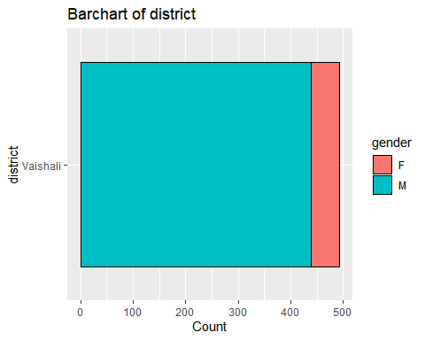

Table 2.2.2 Summary of village

|  |  |  |
| --- | --- | --- |
| village | % Within F | % Within M |
| Askaran Pur | 0.0% | 0.2% |
| Bhathadasi | 20.0% | 16.4% |
| Daulatpur | 5.5% | 2.5% |
| Dohji | 0.0% | 1.1% |
| Hajipur | 3.6% | 7.8% |
| Hilalpur | 3.6% | 3.4% |
| Mahadevmath | 1.8% | 4.3% |
| missing | 32.7% | 21.7% |
| Mukund pur | 3.6% | 5.9% |
| New Daulatpur | 1.8% | 1.8% |
| Panapur | 7.3% | 9.4% |
| Patadh | 7.3% | 9.1% |
| Rajapakar | 3.6% | 3.0% |
| Rampurdilawar | 5.5% | 5.5% |
| Shembho pati | 3.6% | 7.8% |

*Figure 2.2.2* 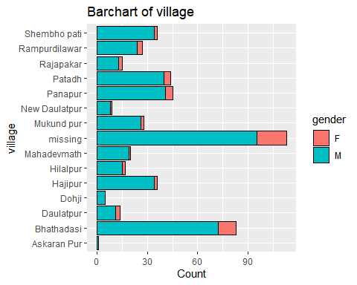

Table 2.2.3 Summary of age

|  |  |  |  |  |  |  |  |
| --- | --- | --- | --- | --- | --- | --- | --- |
|  | Variable | gender | Mean | Median | Minimum | Maximum | Standard.Deviation |
| F | age | F | 43.51 | 40 | 27 | 64 | 11.80 |
| M | age | M | 45.69 | 45 | 27 | 64 | 10.53 |

*Figure 2.2.3* 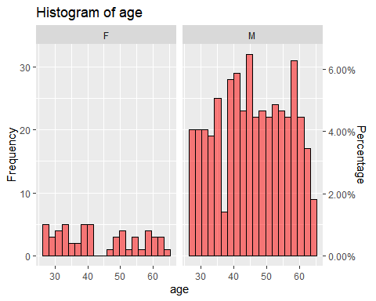

Table 2.2.4 Summary of gender

|  |  |  |
| --- | --- | --- |
| gender | Frequency | % of Respondents |
| F | 55 | 11% |
| M | 438 | 89% |

*Figure 2.2.4* 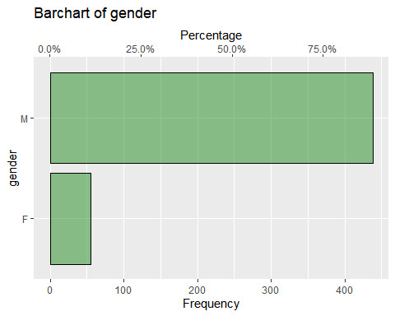

Table 2.2.5 Summary of planting_date

|  |  |  |  |  |  |
| --- | --- | --- | --- | --- | --- |
|  | Variable | gender | Median.Date | Earliest.Date | Final.Date |
| F | planting_date | F | 2014-11-28 | 2014-11-23 | 2014-12-07 |
| M | planting_date | M | 2014-11-29 | 2014-11-20 | 2014-12-07 |

*Figure 2.2.5* 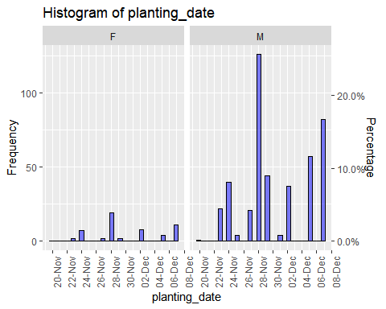

Table 2.3 lists the traits assessed by farmers included in the analysis.

Table 2.3: Traits Assessed

|  |
| --- |
| Traits.Assessed |
| overall |
| germination |
| grainquality |
| yield |

## Location of farmers

*Figure 2.3* 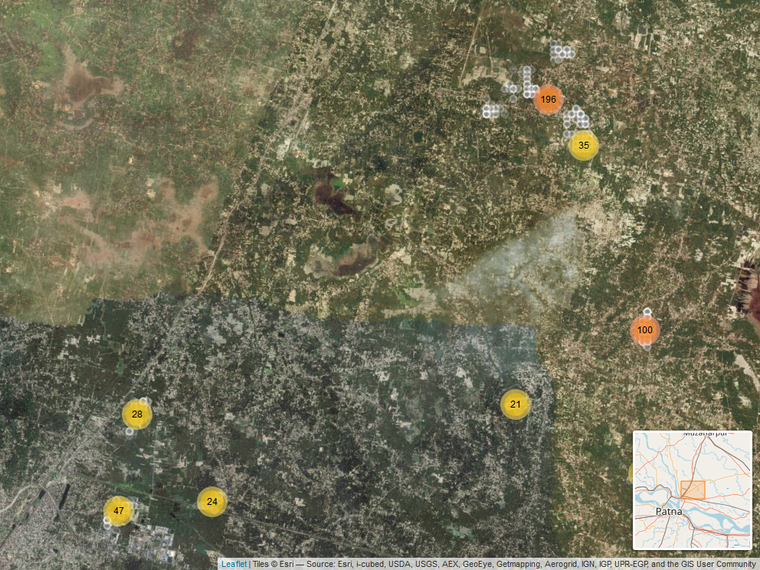

## Assessment of varietys

In this section results are summarised from the data directly, to understand the results and patterns within the data itself. Given the structure of a climmob trail, where each farmer only assesses 3 of the possible varietys these results may be skewed if certain varietys were randomly assigned to face worse varietys than others. This is particularly a potential issue within a smaller trial, as due to the randomisation process the potential for an unbalanced assignment decreases as the sample size increases.

### Overall

Summaries of the overall performance of each of the varietys are summarised in Table 2.4. This shows the % of farmers who assessed the variety as their top ranked of the 3 varietys they were provided, the % of farmers who included the variety as their lowest ranked, the % of ‘head to head contests’ which the variety won and the net favourability score. A score of +100 indicates the variety won all ‘contests’ it was involved in, a score of 0 indicates an equal number of wins and losses, a score of -100 indicates the variety lost all contests.

*Figure 2.4* 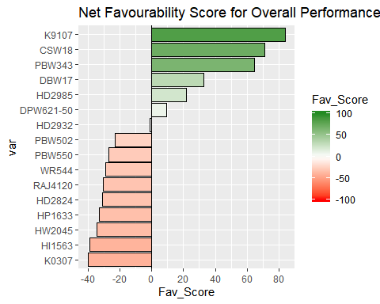

The variety K9107 was the most preferred variety overall being ranked highest by 87.1% of the 93 farmers who assessed this variety.

Other varietys with strong positive rankings were CSW18, PBW343

Table 2.4 - Summary of Overall Performance

|  |  |  |  |  |  |
| --- | --- | --- | --- | --- | --- |
| Variety | N | % Top Ranked | % Bottom Ranked | % Contests Won | Net Favourability Score |
| K9107 | 93 | 87.1% | 3.2% | 91.9% | 83.9 |
| CSW18 | 94 | 78.7% | 7.4% | 85.6% | 71.3 |
| PBW343 | 96 | 72.9% | 8.3% | 82.3% | 64.6 |
| DBW17 | 97 | 47.4% | 14.4% | 66.5% | 33.0 |
| HD2985 | 91 | 44.0% | 22.0% | 61.0% | 22.0 |
| DPW621-50 | 86 | 36.0% | 26.7% | 54.7% | 9.3 |
| HD2932 | 89 | 28.1% | 29.2% | 49.4% | -1.1 |
| PBW502 | 95 | 21.1% | 44.2% | 38.4% | -23.2 |
| PBW550 | 96 | 14.6% | 41.7% | 36.5% | -27.1 |
| WR544 | 93 | 15.1% | 44.1% | 35.5% | -29.0 |
| RAJ4120 | 85 | 16.5% | 47.1% | 34.7% | -30.6 |
| HD2824 | 87 | 14.9% | 46.0% | 34.5% | -31.0 |
| HP1633 | 97 | 16.5% | 49.5% | 33.5% | -33.0 |
| HW2045 | 90 | 12.2% | 46.7% | 32.8% | -34.4 |
| HI1563 | 92 | 10.9% | 50.0% | 30.4% | -39.1 |
| K0307 | 98 | 14.3% | 54.1% | 30.1% | -39.8 |

### Other Traits

Summaries of the results and plots of the net favourability scores are shown below for the other traits marked for inclusion in the analysis.

*germination*

Table 2.5.1: Favourability Statistics for germination

|  |  |  |  |  |  |
| --- | --- | --- | --- | --- | --- |
| variety | N | % Top Ranked | % Bottom Ranked | % Contests Won | Net Favourability Score |
| CSW18 | 94 | 73.4% | 9.6% | 81.9% | 63.8 |
| K9107 | 93 | 69.9% | 15.1% | 77.4% | 54.8 |
| PBW343 | 96 | 64.6% | 12.5% | 76.0% | 52.1 |
| HD2985 | 91 | 40.7% | 23.1% | 58.8% | 17.6 |
| DBW17 | 97 | 37.1% | 22.7% | 57.2% | 14.4 |
| K0307 | 98 | 38.8% | 31.6% | 53.6% | 7.1 |
| HD2932 | 89 | 25.8% | 27.0% | 49.4% | -1.1 |
| DPW621-50 | 86 | 33.7% | 34.9% | 49.4% | -1.2 |
| PBW502 | 95 | 25.3% | 36.8% | 44.2% | -11.6 |
| WR544 | 93 | 21.5% | 40.9% | 40.3% | -19.4 |
| RAJ4120 | 85 | 22.4% | 42.4% | 40.0% | -20.0 |
| PBW550 | 96 | 13.5% | 39.6% | 37.0% | -26.0 |
| HI1563 | 92 | 19.6% | 47.8% | 35.9% | -28.3 |
| HP1633 | 97 | 18.6% | 50.5% | 34.0% | -32.0 |
| HD2824 | 87 | 13.8% | 50.6% | 31.6% | -36.8 |
| HW2045 | 90 | 11.1% | 51.1% | 30.0% | -40.0 |

*Figure 2.5.1* 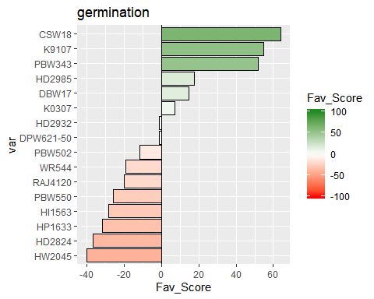

*grainquality*

Table 2.5.2: Favourability Statistics for grainquality

|  |  |  |  |  |  |
| --- | --- | --- | --- | --- | --- |
| variety | N | % Top Ranked | % Bottom Ranked | % Contests Won | Net Favourability Score |
| CSW18 | 94 | 72.3% | 12.8% | 79.8% | 59.6 |
| K9107 | 93 | 71.0% | 16.1% | 77.4% | 54.8 |
| PBW343 | 96 | 63.5% | 13.5% | 75.0% | 50.0 |
| DBW17 | 97 | 37.1% | 22.7% | 57.2% | 14.4 |
| HD2985 | 91 | 37.4% | 24.2% | 56.6% | 13.2 |
| K0307 | 98 | 38.8% | 31.6% | 53.6% | 7.1 |
| DPW621-50 | 86 | 34.9% | 32.6% | 51.2% | 2.3 |
| HD2932 | 89 | 29.2% | 28.1% | 50.6% | 1.1 |
| WR544 | 93 | 23.7% | 36.6% | 43.5% | -12.9 |
| PBW502 | 95 | 23.2% | 40.0% | 41.6% | -16.8 |
| PBW550 | 96 | 15.6% | 37.5% | 39.1% | -21.9 |
| RAJ4120 | 85 | 18.8% | 42.4% | 38.2% | -23.5 |
| HP1633 | 97 | 18.6% | 49.5% | 34.5% | -30.9 |
| HI1563 | 92 | 17.4% | 48.9% | 34.2% | -31.5 |
| HD2824 | 87 | 16.1% | 49.4% | 33.3% | -33.3 |
| HW2045 | 90 | 12.2% | 50.0% | 31.1% | -37.8 |

*Figure 2.5.2* 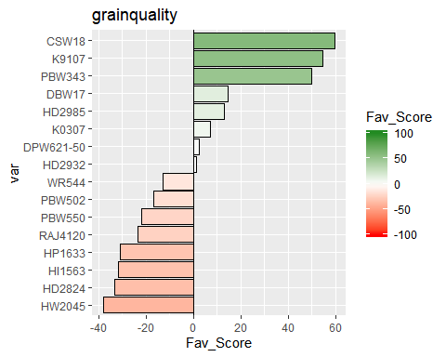

*yield*

Table 2.5.3: Favourability Statistics for yield

|  |  |  |  |  |  |
| --- | --- | --- | --- | --- | --- |
| variety | N | % Top Ranked | % Bottom Ranked | % Contests Won | Net Favourability Score |
| CSW18 | 94 | 77.7% | 11.7% | 83.0% | 66.0 |
| K9107 | 93 | 78.5% | 15.1% | 81.7% | 63.4 |
| PBW343 | 96 | 68.8% | 13.5% | 77.6% | 55.2 |
| HD2985 | 91 | 42.9% | 24.2% | 59.3% | 18.7 |
| DBW17 | 97 | 40.2% | 22.7% | 58.8% | 17.5 |
| HD2932 | 89 | 30.3% | 28.1% | 51.1% | 2.2 |
| DPW621-50 | 86 | 33.7% | 33.7% | 50.0% | 0.0 |
| K0307 | 98 | 23.5% | 31.6% | 45.9% | -8.2 |
| PBW502 | 95 | 25.3% | 38.9% | 43.2% | -13.7 |
| PBW550 | 96 | 17.7% | 37.5% | 40.1% | -19.8 |
| WR544 | 93 | 17.2% | 37.6% | 39.8% | -20.4 |
| RAJ4120 | 85 | 16.5% | 42.4% | 37.1% | -25.9 |
| HP1633 | 97 | 18.6% | 49.5% | 34.5% | -30.9 |
| HD2824 | 87 | 14.9% | 49.4% | 32.8% | -34.5 |
| HI1563 | 92 | 14.1% | 50.0% | 32.1% | -35.9 |
| HW2045 | 90 | 10.0% | 50.0% | 30.0% | -40.0 |

*Figure 2.5.3* 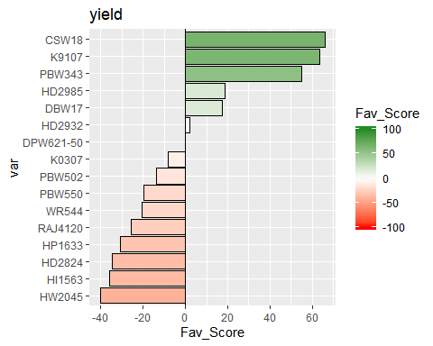

## Pairwise Contests

Appendix B contains the full data for each pairwise comparison of the varieties, which is summarised in the plots below.

### Overall

The figure below shows the outcomes of all pairwise contests between the varietys included in the trial. The variety which won the head-to-head contest is indicated, with the % of times that variety was preferred to the competing variety.

*Figure 2.6* 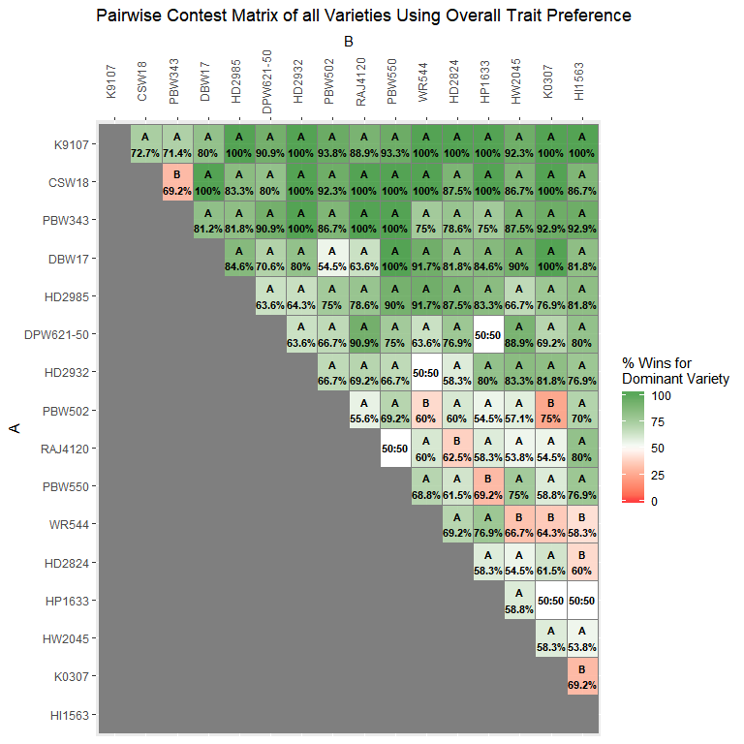

The same information is shown below in bar charts below, showing for each variety the % of times it was preferred over all of the other varietys included when they were assesed by the same farmer.

*Figure 2.7* 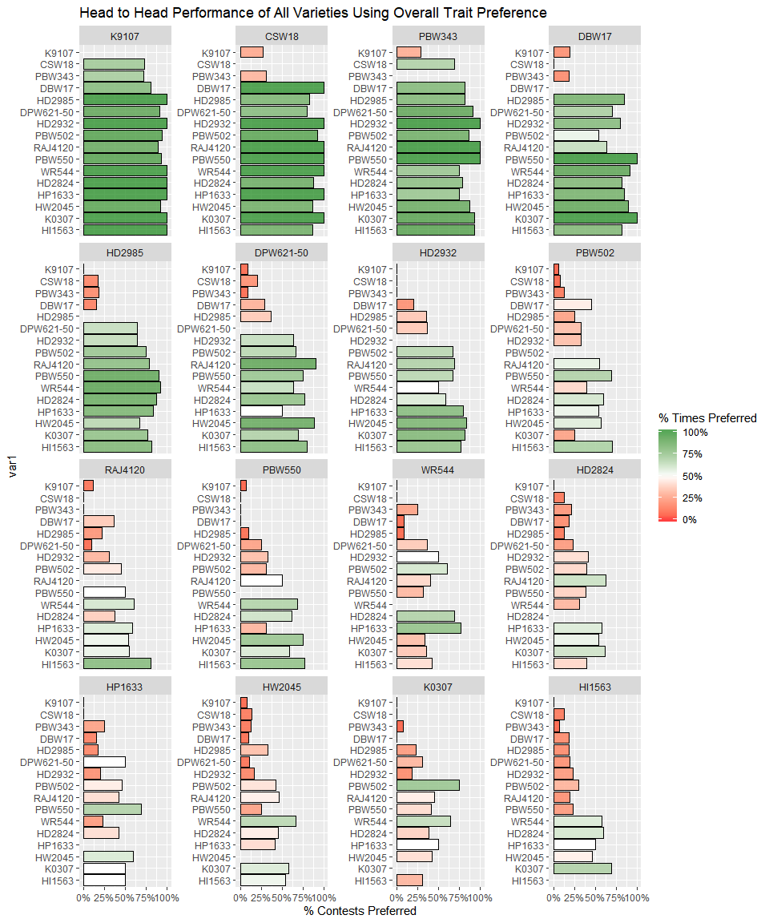

### Other Traits

Results from the pairwise contests of the other individual traits assessed are shown below.

## [1] "germination"

## [1] "grainquality"

## [1] "yield"

*Figure 2.8.1.1* 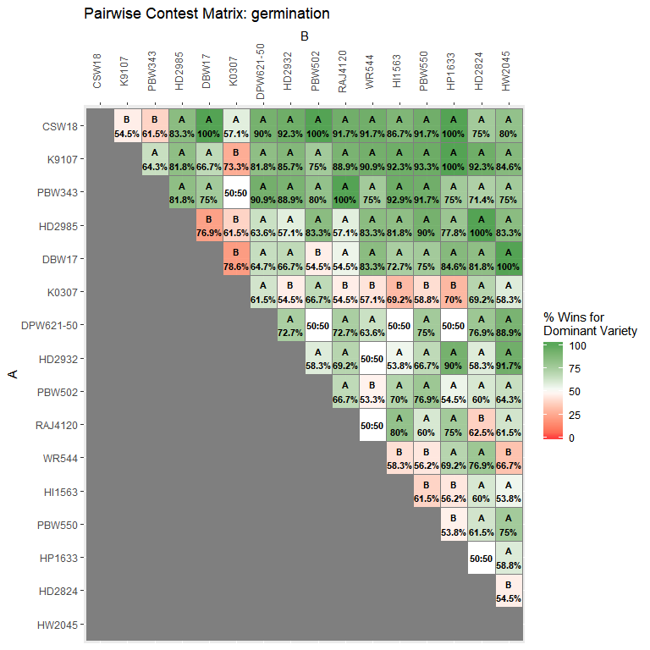

*Figure 2.8.1.2* 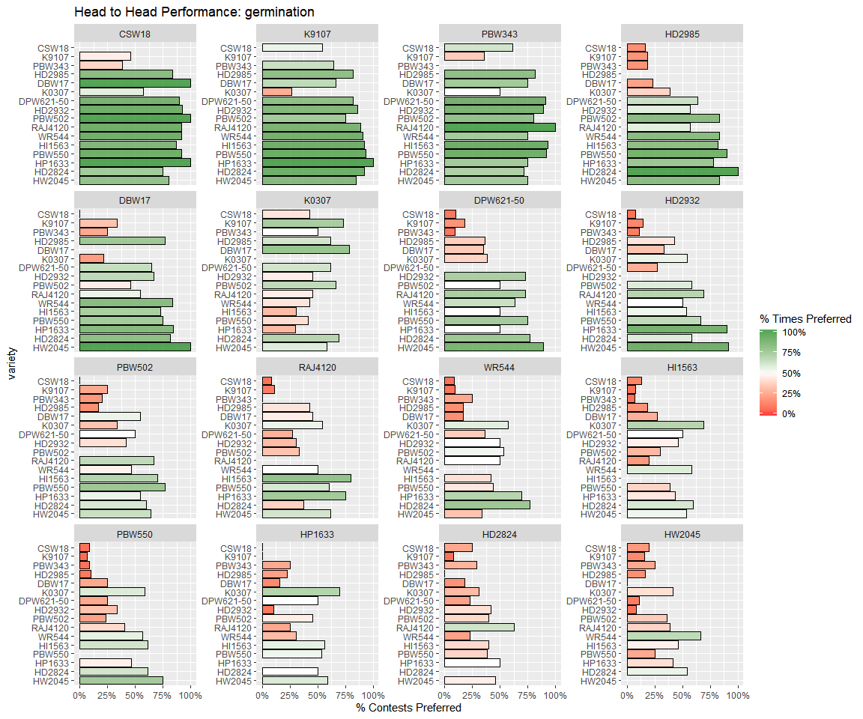

*Figure 2.8.2.1* 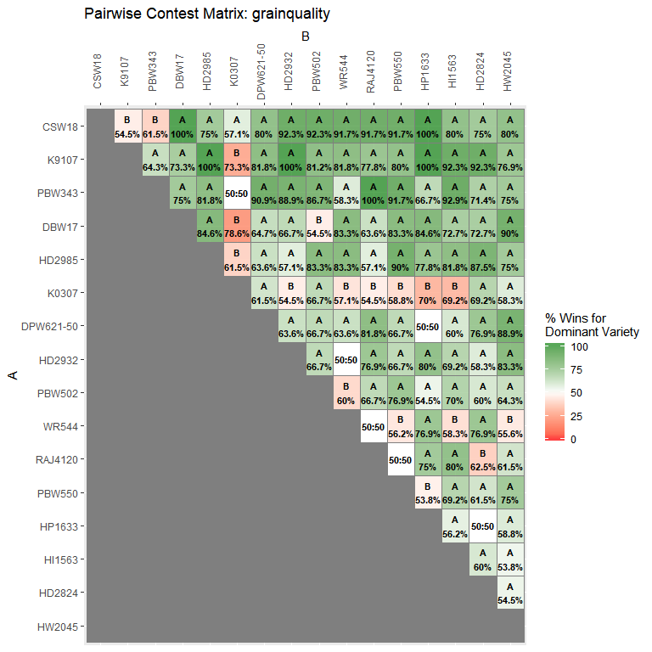

*Figure 2.8.2.2* 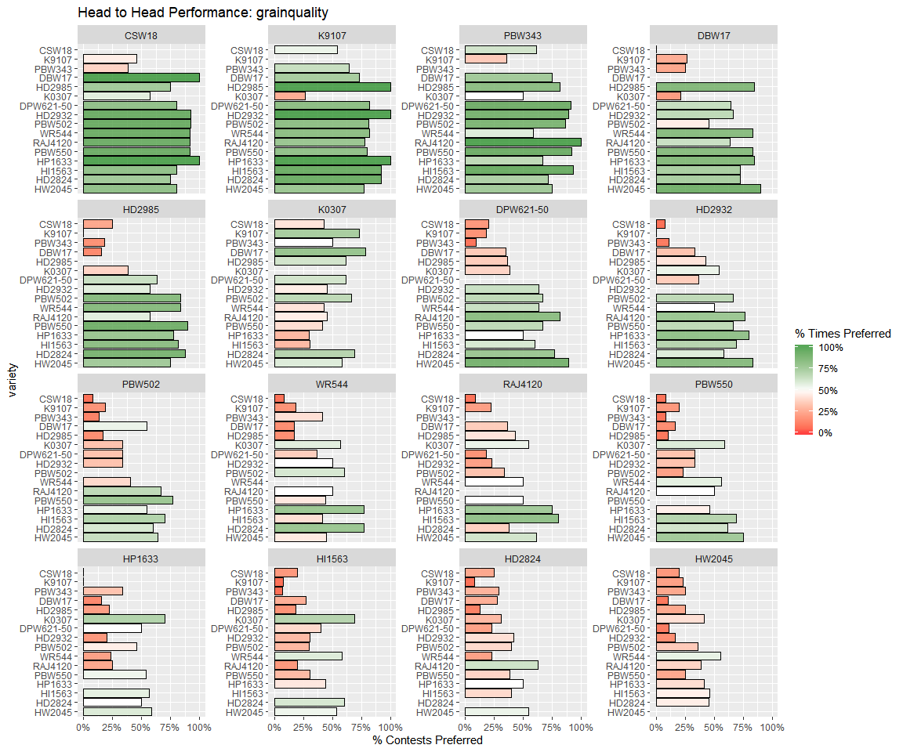

*Figure 2.8.3.1* 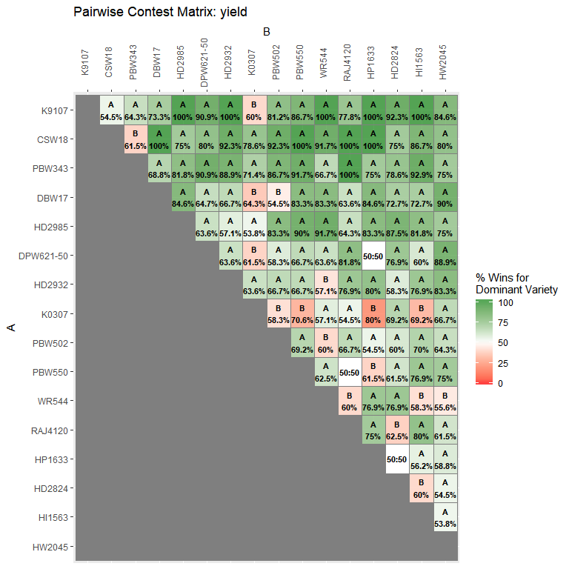

*Figure 2.8.3.2* 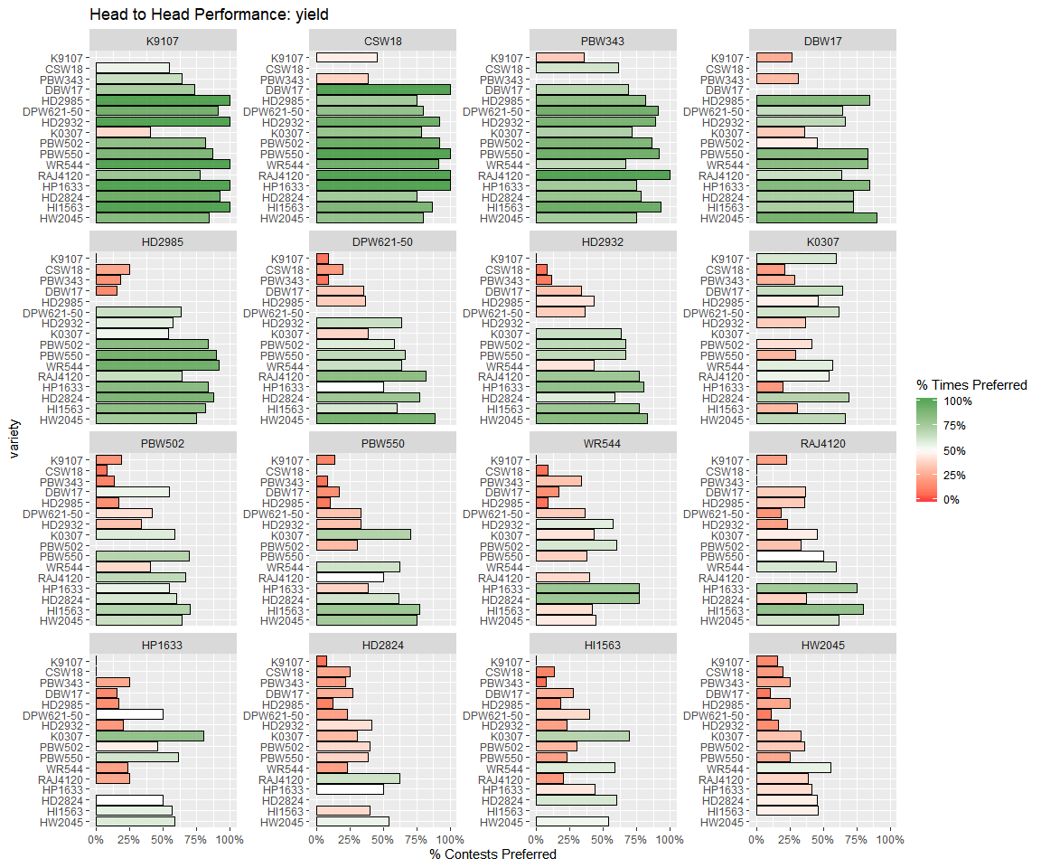

## Relationship between traits

Table 2.9 shows the relationship between the individual trait rankings and the overall rankings.

Table 2.9: Relationship between individual trait assessment and overall assesment

|  |  |  |  |
| --- | --- | --- | --- |
| trait | Overall % Agreement | % Agreement with Overall Best | % Agreement with Overall Worst |
| germination | 74% | 81% | 78% |
| grainquality | 78% | 84% | 81% |
| yield | 81% | 91% | 81% |

*Figure 2.9* 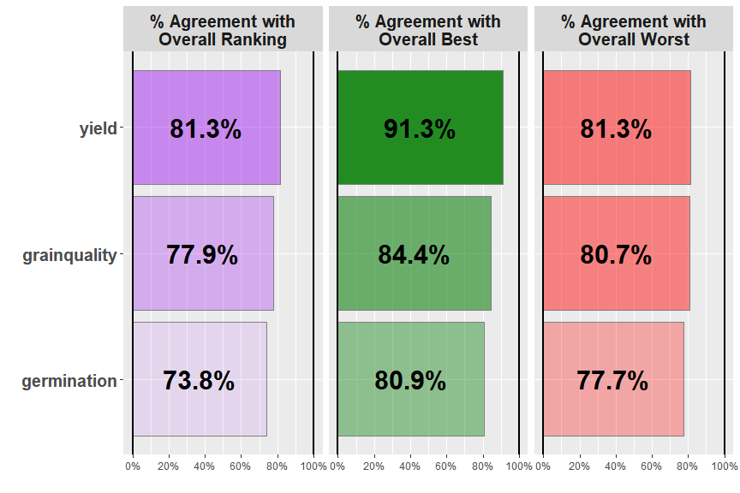

Overall the trait which had the strongest relationship with the overall ranking was germination, with identical rankings being given as the overall ranking 81% of the time.

# Section 3: Plackett-Luce Models of Ranking Differences

Table 3.1 shows the results from the likelihood ratio test from the Plackett-Luce model for overall rankings of the different varietys. The hypothesis being tested is that there is no difference in the assessments of any of the different varietys.

Table 3.1: Likelihood ratio test results from overall model

|  |  |  |  |  |
| --- | --- | --- | --- | --- |
| model | logLikelihood | DF | Statistic | Pr(>Chisq) |
| NULL | -883.3374 | 1479 | NA | NA |
| mod_overall | -669.5161 | 1464 | 427.6427 | < 2.22e-16 *** |

p=< 2.22e-16. This suggests that from the experiment shows there is strong evidence of a difference betweenvarietys

Figure 3.1 shows the estimates of the model coefficients with 84% confidence intervals and mean seperation analysis conducted. The purpose of this graph is to be able to best distinguish between the relative strength of each of the varietys assessed. As such the coefficient estimates themselves are not directly interpretable as numbers, however a higher value for the coefficient indicates that a variety has been more preferred. The 84% confidence width is chosen so that non-overlapping confidence intervals could be interpreted as indicating significant differences at the 5% significance level. This may not match exactly with the mean seperation groupings, as these groupings also take into account multiple testing through the Benjamini and Hochberg adjustment.

*Figure 3.1 - Overall Ranking: Model Coefficients and Mean Separation* 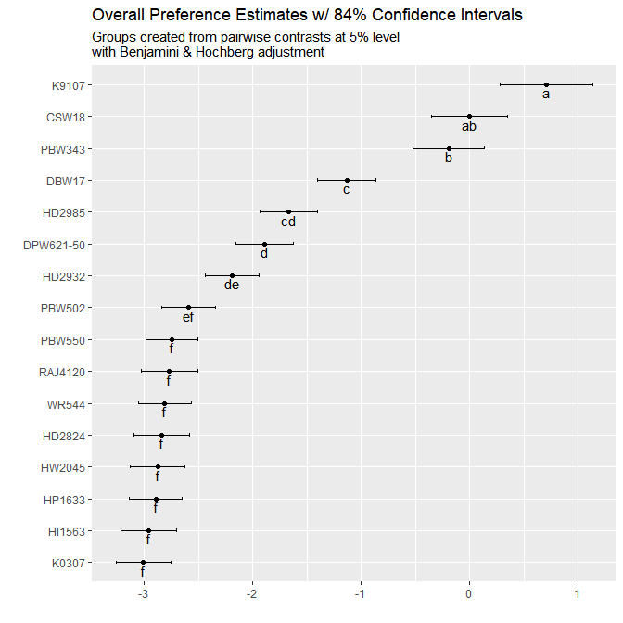

The same information as Figure 3.1 is shown in Table 3.2 below

Table 3.2 - Model Coefficients and Mean Separation ofvarietys at 5% Level with Benjamini & Hochberg adjustment

|  |  |  |  |
| --- | --- | --- | --- |
|  | Estimate | quasiSE | Group |
| K9107 | 0.71 | 0.30 | a |
| CSW18 | 0.00 | 0.25 | ab |
| PBW343 | -0.19 | 0.23 | b |
| DBW17 | -1.13 | 0.19 | c |
| HD2985 | -1.67 | 0.19 | cd |
| DPW621-50 | -1.89 | 0.19 | d |
| HD2932 | -2.19 | 0.18 | de |
| PBW502 | -2.59 | 0.18 | ef |
| PBW550 | -2.74 | 0.17 | f |
| RAJ4120 | -2.77 | 0.19 | f |
| WR544 | -2.81 | 0.17 | f |
| HD2824 | -2.84 | 0.18 | f |
| HW2045 | -2.88 | 0.18 | f |
| HP1633 | -2.90 | 0.18 | f |
| HI1563 | -2.96 | 0.18 | f |
| K0307 | -3.01 | 0.18 | f |

Table 3.3 and Figure 3.2 use the coefficients from the model to estimate the probability of each variety being considered to be the top ranked variety in a direct comparison between all of the possible varities.

Table 3.3: Percentage probability of being the highest ranked overall

|  |  |  |
| --- | --- | --- |
|  | Variety | X..Probability |
| K9107 | K9107 | 39.3% |
| CSW18 | CSW18 | 19.4% |
| PBW343 | PBW343 | 16.0% |
| DBW17 | DBW17 | 6.3% |
| HD2985 | HD2985 | 3.7% |
| DPW621-50 | DPW621-50 | 2.9% |
| HD2932 | HD2932 | 2.2% |
| PBW502 | PBW502 | 1.5% |
| PBW550 | PBW550 | 1.2% |
| RAJ4120 | RAJ4120 | 1.2% |
| WR544 | WR544 | 1.2% |
| HD2824 | HD2824 | 1.1% |
| HW2045 | HW2045 | 1.1% |
| HP1633 | HP1633 | 1.1% |
| HI1563 | HI1563 | 1.0% |
| K0307 | K0307 | 1.0% |

*Figure 3.2 - Overall Ranking: Probability of Being The Highest Ranked Overall* 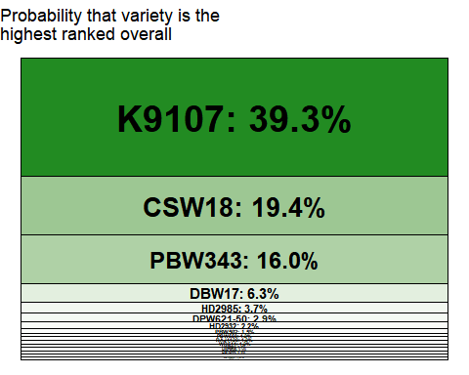

germination

Table 3.4.1

|  |  |  |  |  |
| --- | --- | --- | --- | --- |
| model | logLikelihood | DF | Statistic | Pr(>Chisq) |
| NULL | -883.3374 | 1479 | NA | NA |
| NA | -767.4869 | 1464 | 231.7009 | < 2.22e-16 *** |

p=< 2.22e-16 , this suggests that from the experiment shows there is strong evidence of a difference betweenvarietys

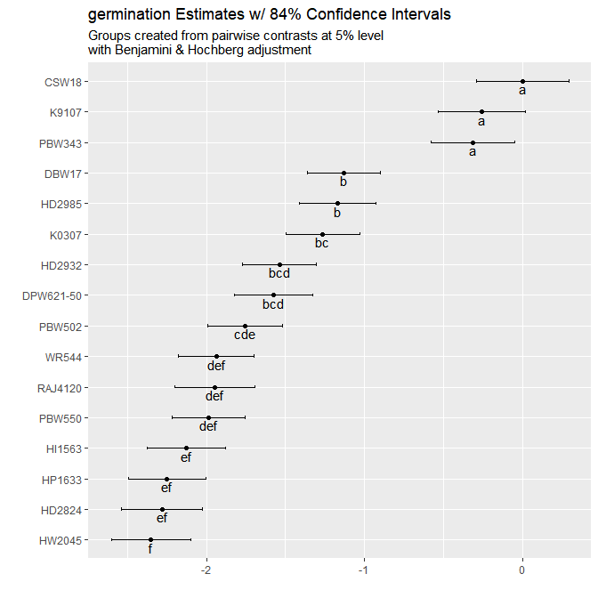

Table 3.5. 1 germination model parameter estimates

|  |  |  |  |
| --- | --- | --- | --- |
|  | Estimate | quasiSE | Group |
| CSW18 | 0.00 | 0.21 | a |
| K9107 | -0.26 | 0.20 | a |
| PBW343 | -0.31 | 0.19 | a |
| DBW17 | -1.13 | 0.16 | b |
| HD2985 | -1.17 | 0.17 | b |
| K0307 | -1.26 | 0.17 | bc |
| HD2932 | -1.54 | 0.17 | bcd |
| DPW621-50 | -1.58 | 0.18 | bcd |
| PBW502 | -1.76 | 0.17 | cde |
| WR544 | -1.94 | 0.17 | def |
| RAJ4120 | -1.95 | 0.18 | def |
| PBW550 | -1.99 | 0.16 | def |
| HI1563 | -2.13 | 0.18 | ef |
| HP1633 | -2.25 | 0.17 | ef |
| HD2824 | -2.28 | 0.18 | ef |
| HW2045 | -2.35 | 0.18 | f |

Table 3.6. 1 Probability of being highest ranked: germination

|  |  |  |
| --- | --- | --- |
|  | Variety | Probability |
| CSW18 | CSW18 | 20.6% |
| K9107 | K9107 | 15.9% |
| PBW343 | PBW343 | 15.0% |
| DBW17 | DBW17 | 6.6% |
| HD2985 | HD2985 | 6.4% |
| K0307 | K0307 | 5.8% |
| HD2932 | HD2932 | 4.4% |
| DPW621-50 | DPW621-50 | 4.3% |
| PBW502 | PBW502 | 3.6% |
| WR544 | WR544 | 3.0% |
| RAJ4120 | RAJ4120 | 2.9% |
| PBW550 | PBW550 | 2.8% |
| HI1563 | HI1563 | 2.4% |
| HP1633 | HP1633 | 2.2% |
| HD2824 | HD2824 | 2.1% |
| HW2045 | HW2045 | 2.0% |

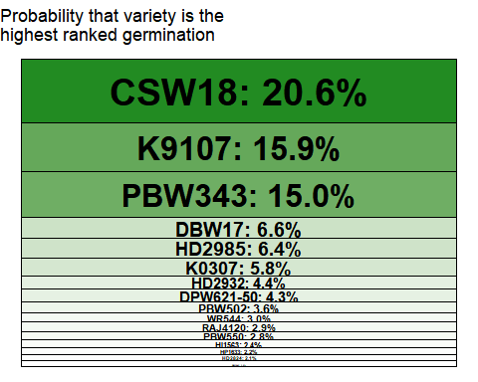

grainquality

Table 3.4.2

|  |  |  |  |  |
| --- | --- | --- | --- | --- |
| model | logLikelihood | DF | Statistic | Pr(>Chisq) |
| NULL | -883.3374 | 1479 | NA | NA |
| NA | -779.4795 | 1464 | 207.7158 | < 2.22e-16 *** |

p=< 2.22e-16 , this suggests that from the experiment shows there is strong evidence of a difference betweenvarietys

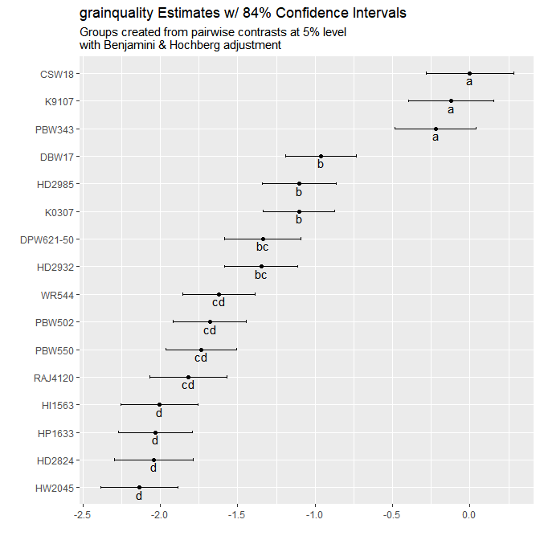

Table 3.5. 2 grainquality model parameter estimates

|  |  |  |  |
| --- | --- | --- | --- |
|  | Estimate | quasiSE | Group |
| CSW18 | 0.00 | 0.20 | a |
| K9107 | -0.12 | 0.20 | a |
| PBW343 | -0.22 | 0.19 | a |
| DBW17 | -0.96 | 0.16 | b |
| HD2985 | -1.10 | 0.17 | b |
| K0307 | -1.10 | 0.17 | b |
| DPW621-50 | -1.34 | 0.18 | bc |
| HD2932 | -1.35 | 0.17 | bc |
| WR544 | -1.62 | 0.17 | cd |
| PBW502 | -1.68 | 0.17 | cd |
| PBW550 | -1.74 | 0.16 | cd |
| RAJ4120 | -1.82 | 0.18 | cd |
| HI1563 | -2.01 | 0.18 | d |
| HP1633 | -2.03 | 0.17 | d |
| HD2824 | -2.04 | 0.18 | d |
| HW2045 | -2.14 | 0.18 | d |

Table 3.6. 2 Probability of being highest ranked: grainquality

|  |  |  |
| --- | --- | --- |
|  | Variety | Probability |
| CSW18 | CSW18 | 18.2% |
| K9107 | K9107 | 16.1% |
| PBW343 | PBW343 | 14.6% |
| DBW17 | DBW17 | 7.0% |
| HD2985 | HD2985 | 6.0% |
| K0307 | K0307 | 6.0% |
| DPW621-50 | DPW621-50 | 4.8% |
| HD2932 | HD2932 | 4.7% |
| WR544 | WR544 | 3.6% |
| PBW502 | PBW502 | 3.4% |
| PBW550 | PBW550 | 3.2% |
| RAJ4120 | RAJ4120 | 3.0% |
| HI1563 | HI1563 | 2.5% |
| HP1633 | HP1633 | 2.4% |
| HD2824 | HD2824 | 2.4% |
| HW2045 | HW2045 | 2.2% |

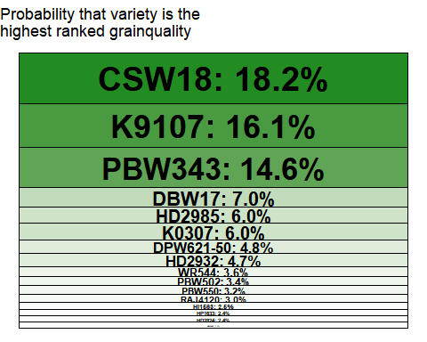

yield

Table 3.4.3

|  |  |  |  |  |
| --- | --- | --- | --- | --- |
| model | logLikelihood | DF | Statistic | Pr(>Chisq) |
| NULL | -883.3374 | 1479 | NA | NA |
| NA | -757.1338 | 1464 | 252.4072 | < 2.22e-16 *** |

p=< 2.22e-16 , this suggests that from the experiment shows there is strong evidence of a difference betweenvarietys

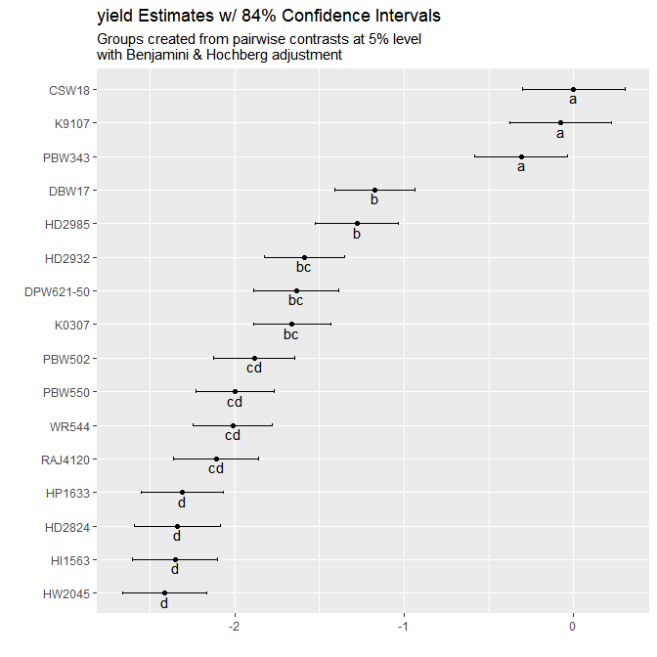

Table 3.5. 3 yield model parameter estimates

|  |  |  |  |
| --- | --- | --- | --- |
|  | Estimate | quasiSE | Group |
| CSW18 | 0.00 | 0.21 | a |
| K9107 | -0.08 | 0.21 | a |
| PBW343 | -0.31 | 0.20 | a |
| DBW17 | -1.17 | 0.17 | b |
| HD2985 | -1.28 | 0.17 | b |
| HD2932 | -1.59 | 0.17 | bc |
| DPW621-50 | -1.64 | 0.18 | bc |
| K0307 | -1.66 | 0.16 | bc |
| PBW502 | -1.88 | 0.17 | cd |
| PBW550 | -2.00 | 0.16 | cd |
| WR544 | -2.01 | 0.17 | cd |
| RAJ4120 | -2.11 | 0.18 | cd |
| HP1633 | -2.31 | 0.17 | d |
| HD2824 | -2.34 | 0.18 | d |
| HI1563 | -2.35 | 0.18 | d |
| HW2045 | -2.41 | 0.18 | d |

Table 3.6. 3 Probability of being highest ranked: yield

|  |  |  |
| --- | --- | --- |
|  | Variety | Probability |
| CSW18 | CSW18 | 21.0% |
| K9107 | K9107 | 19.4% |
| PBW343 | PBW343 | 15.4% |
| DBW17 | DBW17 | 6.5% |
| HD2985 | HD2985 | 5.9% |
| HD2932 | HD2932 | 4.3% |
| DPW621-50 | DPW621-50 | 4.1% |
| K0307 | K0307 | 4.0% |
| PBW502 | PBW502 | 3.2% |
| PBW550 | PBW550 | 2.9% |
| WR544 | WR544 | 2.8% |
| RAJ4120 | RAJ4120 | 2.5% |
| HP1633 | HP1633 | 2.1% |
| HD2824 | HD2824 | 2.0% |
| HI1563 | HI1563 | 2.0% |
| HW2045 | HW2045 | 1.9% |

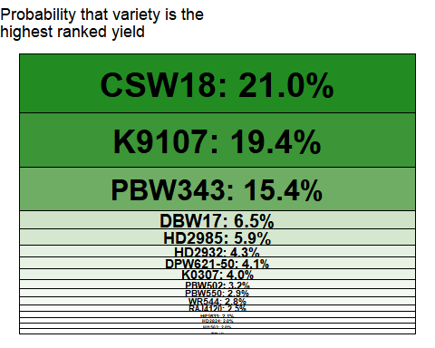

# Section 4: Plackett Luce Models With Covariates

## Overall Ranking

A summary of the signifance levels for each of the covariates that were able to be tested is shown in Table 4.1 for the most significantly different subgroups that can be determined using just the individual variable.

Table 4.1: Summary of univariate p-values for first split in Plackett-Luce tree model for the overall ranking

|  |  |
| --- | --- |
| Variable | p |
| age | 0.98247 |
| gender | 0.99846 |
| planting_date | 0.70342 |
| lon | 1.8724e-06 *** |
| lat | 7.1691e-09 *** |

Figure 4.1 shows the partitioning of the rankings based on the most significantly different sub-groups which could be identified from the data.

*Figure 4.1 - Overall Ranking Plackett-Luce Tree Considering All Possible Covariates* 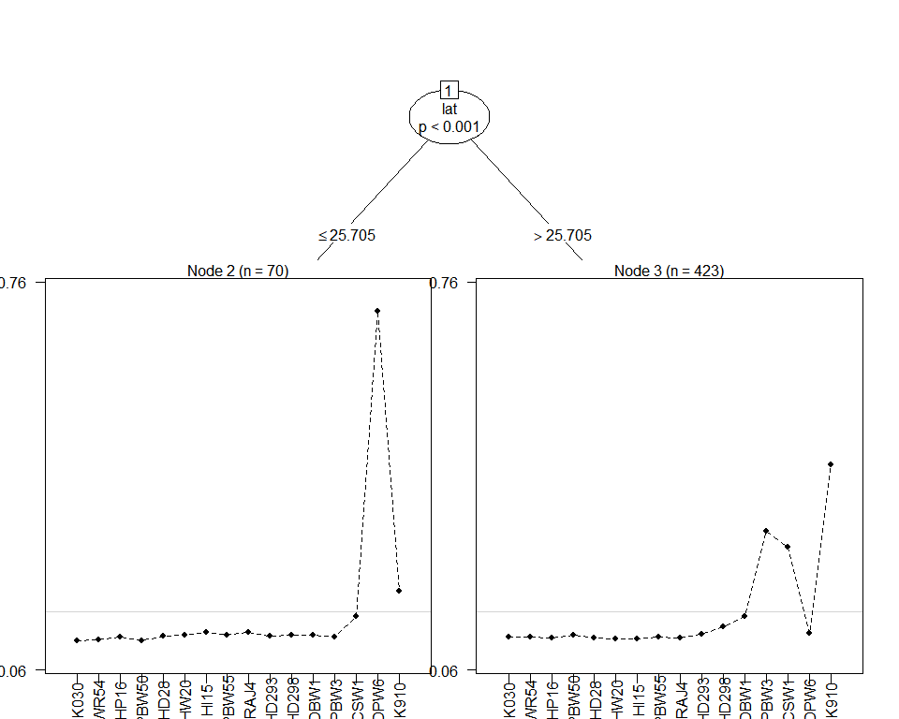

The highest and lowest performing variety within each sub-group is identified within Table 4.2.

Table 4.2 - Summary of Performance in Each Node

|  |  |  |  |
| --- | --- | --- | --- |
| Subgroup | Number of Respondents | Best Ranked Varieties | Worst Ranked Varieties |
| lat <= 25.705 | 70 | DPW621-50, K9107, CSW18 | K0307, PBW502, WR544 |
| lat > 25.705 | 423 | K9107, PBW343, CSW18 | HI1563, HW2045, HP1633, HD2824, RAJ4120, PBW550 |

The model coefficient estimates, along with 84% confidence intervals are provided in Figure 4.2. This will help identification of which varietys were better suited to particular sub-groups identified by the analysis.

*Figure 4.2 - Coefficient Estimates Within Each Identified Terminal Node Subgroup* 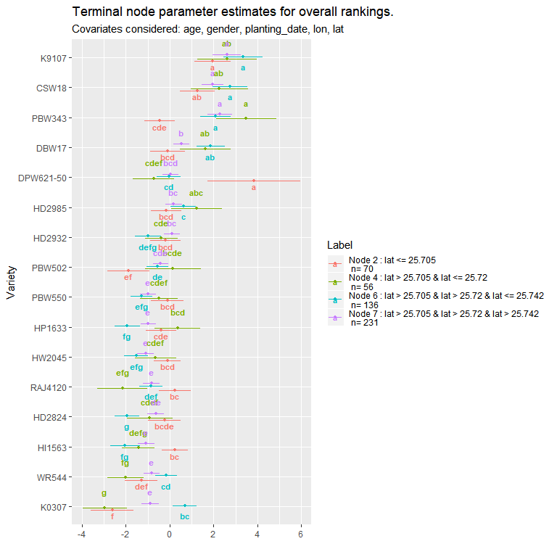

Table 4.3 outlines the p-values for each covariate at each of the nodes in the tree, outlining whether a significant split could be determined from within the existing sub-group at that node.

Table 4.3: p-values for effect of each covariate at each node

|  |  |  |  |
| --- | --- | --- | --- |
| parameter | Node | statistic | p |
| age | 1 | 24.46939 | 0.98247 |
| gender | 1 | 11.36542 | 0.99846 |
| planting_date | 1 | 29.80551 | 0.70342 |
| lon | 1 | 68.20674 | 1.8724e-06 |
| lat | 1 | 81.12984 | 7.1691e-09 |
| age | 3 | 28.17210 | 0.81126 |
| gender | 3 | 13.11164 | 0.98892 |
| planting_date | 3 | 31.97724 | 0.48234 |
| lon | 3 | 25.96659 | 0.93536 |
| lat | 3 | 37.62144 | 0.12913 |

## Univariate analysis

district not considered as a covariate - only 1 unique value

village not considered as a covariate - not all varieties observed within all groups

### age

Variable not found to be statistically signifcant at 5% level. p= 0.5546

### gender

Variable not found to be statistically signifcant at 5% level. p= 0.7263

### planting_date

Variable not found to be statistically signifcant at 5% level. p= 0.2158

### lon

*Figure 4.4.6* 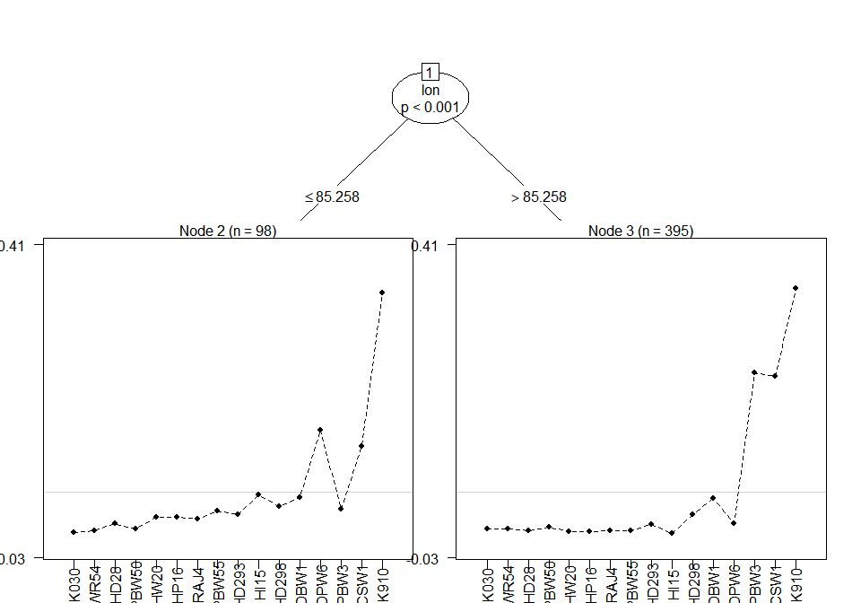

*Figure 4.5.6*

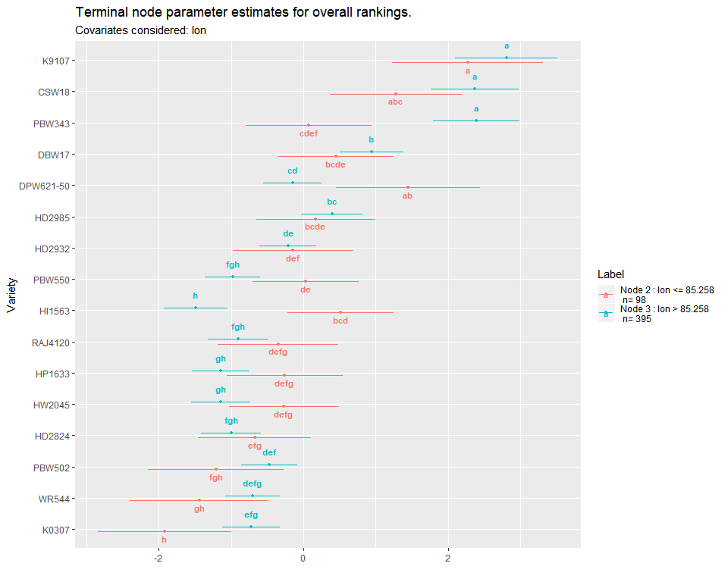

### lat

*Figure 4.4.7* 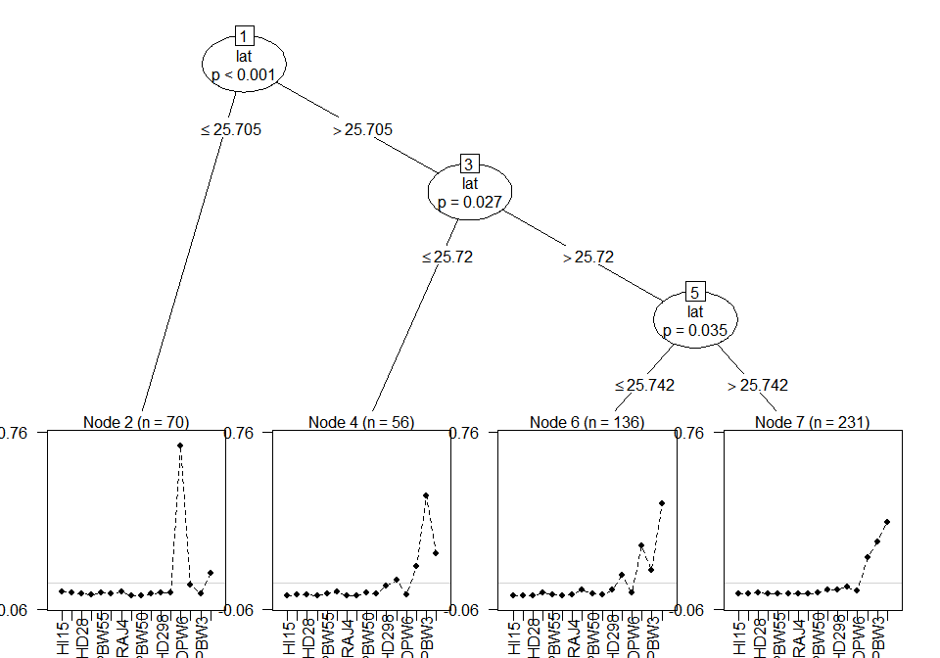

*Figure 4.5.7*

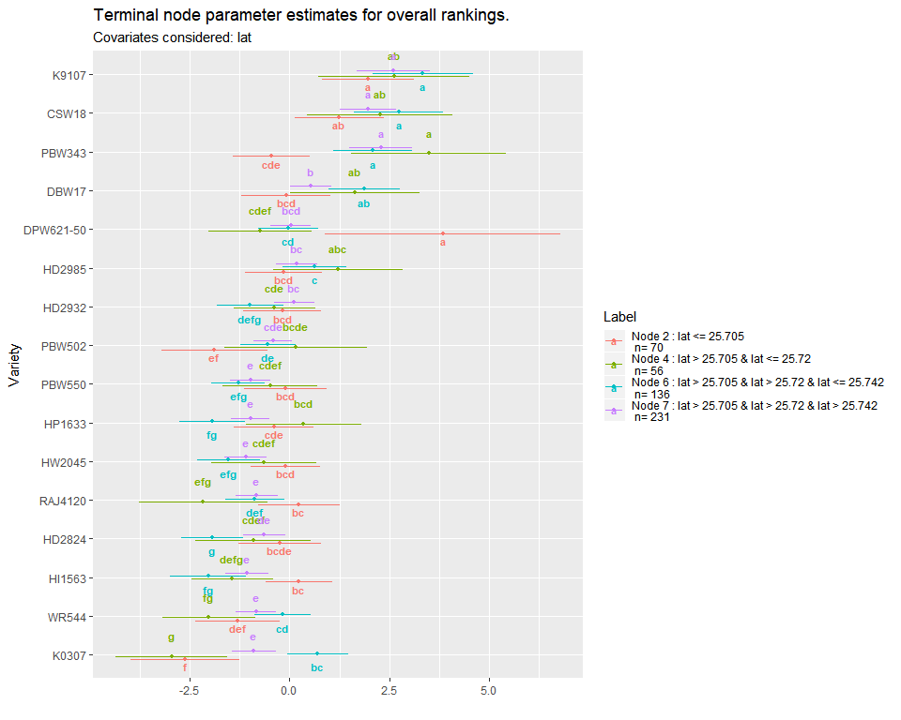

# Section 5: Relationship between Traits

Partial least squares regression was used to determine relationship between the specific traits and the overall rankings.

*Figure 5.1 - Partial Least Squares Biplot of Relationship Between Traits and Overall Performance* 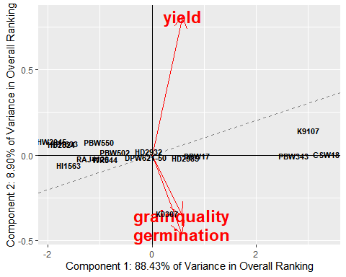

The first two components recombining the specific traits are able to explain 97.3% of the variability in the overall ranking. The dashed line represents the overall ranking, with an increase in performance with an increase in the x and y axes.

Varieties positioned close to the dashed line will be performing equally across all traits; varieties positioned further away from the dashed line will have varying performance in different traits, with better performance in traits with arrows pointing in the direction away from the dashed line and worse perforance in traits pointing in the opposite direction.

Traits with arrows pointing in similar directions have a similar relationship to the overall ranking. Traits with arrows more closely following the dashed line will have a stronger relationship to the overall ranking.

*Table 5.1 - Partial Least Squares Regression Model Of Traits Against Overall Ranking*

## Response Overall (3 comps):  
## Estimate Std. Error Df t value Pr(>|t|)   
## germination -1.28693 0.82271 15 -1.5642 0.1386   
## grainquality -0.74222 0.75526 15 -0.9827 0.3413   
## yield 3.17161 0.42724 15 7.4236 2.136e-06 ***  
## ---  
## Signif. codes: 0 '***' 0.001 '**' 0.01 '*' 0.05 '.' 0.1 ' ' 1

Table 5.1 summarises the regression model between the rankings of each trait of an individual variety and the overall ranking. Due to the strong correlation in rankings for different traits it would be expected for some of these coefficients to be negative. So an individual negative value does not neccesarily indicate a negative relationship overall between that trait and the overall ranking; rather that holding all other rankings constant and increase ranking for that trait would not be e

# Appendix A: Summary of Fixed Parameters Used

TBD

# Appendix B: All Pairwise Treatment Contests

Pairwise: % of Contests Where Variety 1 Was Preferred to Variety 2

|  |  |  |  |  |  |  |
| --- | --- | --- | --- | --- | --- | --- |
| Variety 1 | Variety 2 | Number of Contests | Overall | germination | grainquality | yield |
| CSW18 | DBW17 | 13 | 100% | 100% | 100% | 100% |
| CSW18 | DPW621-50 | 10 | 80% | 90% | 80% | 80% |
| CSW18 | HD2824 | 8 | 88% | 75% | 75% | 75% |
| CSW18 | HD2932 | 13 | 100% | 92% | 92% | 92% |
| CSW18 | HD2985 | 12 | 83% | 83% | 75% | 75% |
| CSW18 | HI1563 | 15 | 87% | 87% | 80% | 87% |
| CSW18 | HP1633 | 15 | 100% | 100% | 100% | 100% |
| CSW18 | HW2045 | 15 | 87% | 80% | 80% | 80% |
| CSW18 | K0307 | 14 | 100% | 57% | 57% | 79% |
| CSW18 | K9107 | 11 | 27% | 45% | 45% | 45% |
| CSW18 | PBW343 | 13 | 31% | 38% | 38% | 38% |
| CSW18 | PBW502 | 13 | 92% | 100% | 92% | 92% |
| CSW18 | PBW550 | 12 | 100% | 92% | 92% | 100% |
| CSW18 | RAJ4120 | 12 | 100% | 92% | 92% | 100% |
| CSW18 | WR544 | 12 | 100% | 92% | 92% | 92% |
| DBW17 | CSW18 | 13 | 0% | 0% | 0% | 0% |
| DBW17 | DPW621-50 | 17 | 71% | 65% | 65% | 65% |
| DBW17 | HD2824 | 11 | 82% | 82% | 73% | 73% |
| DBW17 | HD2932 | 15 | 80% | 67% | 67% | 67% |
| DBW17 | HD2985 | 13 | 85% | 77% | 85% | 85% |
| DBW17 | HI1563 | 11 | 82% | 73% | 73% | 73% |
| DBW17 | HP1633 | 13 | 85% | 85% | 85% | 85% |
| DBW17 | HW2045 | 10 | 90% | 100% | 90% | 90% |
| DBW17 | K0307 | 14 | 100% | 21% | 21% | 36% |
| DBW17 | K9107 | 15 | 20% | 33% | 27% | 27% |
| DBW17 | PBW343 | 16 | 19% | 25% | 25% | 31% |
| DBW17 | PBW502 | 11 | 55% | 45% | 45% | 45% |
| DBW17 | PBW550 | 12 | 100% | 75% | 83% | 83% |
| DBW17 | RAJ4120 | 11 | 64% | 55% | 64% | 64% |
| DBW17 | WR544 | 12 | 92% | 83% | 83% | 83% |
| DPW621.50 | CSW18 | 10 | 20% | 10% | 20% | 20% |
| DPW621.50 | DBW17 | 17 | 29% | 35% | 35% | 35% |
| DPW621.50 | DPW621-50 | NA | NA% | NA% | NA% | NA% |
| DPW621.50 | HD2824 | 13 | 77% | 77% | 77% | 77% |
| DPW621.50 | HD2932 | 11 | 64% | 73% | 64% | 64% |
| DPW621.50 | HD2985 | 11 | 36% | 36% | 36% | 36% |
| DPW621.50 | HI1563 | 10 | 80% | 50% | 60% | 60% |
| DPW621.50 | HP1633 | 10 | 50% | 50% | 50% | 50% |
| DPW621.50 | HW2045 | 9 | 89% | 89% | 89% | 89% |
| DPW621.50 | K0307 | 13 | 69% | 38% | 38% | 38% |
| DPW621.50 | K9107 | 11 | 9% | 18% | 18% | 9% |
| DPW621.50 | PBW343 | 11 | 9% | 9% | 9% | 9% |
| DPW621.50 | PBW502 | 12 | 67% | 50% | 67% | 58% |
| DPW621.50 | PBW550 | 12 | 75% | 75% | 67% | 67% |
| DPW621.50 | RAJ4120 | 11 | 91% | 73% | 82% | 82% |
| DPW621.50 | WR544 | 11 | 64% | 64% | 64% | 64% |
| HD2824 | CSW18 | 8 | 12% | 25% | 25% | 25% |
| HD2824 | DBW17 | 11 | 18% | 18% | 27% | 27% |
| HD2824 | DPW621-50 | 13 | 23% | 23% | 23% | 23% |
| HD2824 | HD2932 | 12 | 42% | 42% | 42% | 42% |
| HD2824 | HD2985 | 8 | 12% | 0% | 12% | 12% |
| HD2824 | HI1563 | 10 | 40% | 40% | 40% | 40% |
| HD2824 | HP1633 | 12 | 58% | 50% | 50% | 50% |
| HD2824 | HW2045 | 11 | 55% | 45% | 55% | 55% |
| HD2824 | K0307 | 13 | 62% | 31% | 31% | 31% |
| HD2824 | K9107 | 13 | 0% | 8% | 8% | 8% |
| HD2824 | PBW343 | 14 | 21% | 29% | 29% | 21% |
| HD2824 | PBW502 | 15 | 40% | 40% | 40% | 40% |
| HD2824 | PBW550 | 13 | 38% | 38% | 38% | 38% |
| HD2824 | RAJ4120 | 8 | 62% | 62% | 62% | 62% |
| HD2824 | WR544 | 13 | 31% | 23% | 23% | 23% |
| HD2932 | CSW18 | 13 | 0% | 8% | 8% | 8% |
| HD2932 | DBW17 | 15 | 20% | 33% | 33% | 33% |
| HD2932 | DPW621-50 | 11 | 36% | 27% | 36% | 36% |
| HD2932 | HD2824 | 12 | 58% | 58% | 58% | 58% |
| HD2932 | HD2985 | 14 | 36% | 43% | 43% | 43% |
| HD2932 | HI1563 | 13 | 77% | 54% | 69% | 77% |
| HD2932 | HP1633 | 10 | 80% | 90% | 80% | 80% |
| HD2932 | HW2045 | 12 | 83% | 92% | 83% | 83% |
| HD2932 | K0307 | 11 | 82% | 55% | 55% | 64% |
| HD2932 | K9107 | 7 | 0% | 14% | 0% | 0% |
| HD2932 | PBW343 | 9 | 0% | 11% | 11% | 11% |
| HD2932 | PBW502 | 12 | 67% | 58% | 67% | 67% |
| HD2932 | PBW550 | 12 | 67% | 67% | 67% | 67% |
| HD2932 | RAJ4120 | 13 | 69% | 69% | 77% | 77% |
| HD2932 | WR544 | 14 | 50% | 50% | 50% | 43% |
| HD2985 | CSW18 | 12 | 17% | 17% | 25% | 25% |
| HD2985 | DBW17 | 13 | 15% | 23% | 15% | 15% |
| HD2985 | DPW621-50 | 11 | 64% | 64% | 64% | 64% |
| HD2985 | HD2824 | 8 | 88% | 100% | 88% | 88% |
| HD2985 | HD2932 | 14 | 64% | 57% | 57% | 57% |
| HD2985 | HI1563 | 11 | 82% | 82% | 82% | 82% |
| HD2985 | HP1633 | 18 | 83% | 78% | 78% | 83% |
| HD2985 | HW2045 | 12 | 67% | 83% | 75% | 75% |
| HD2985 | K0307 | 13 | 77% | 38% | 38% | 54% |
| HD2985 | K9107 | 11 | 0% | 18% | 0% | 0% |
| HD2985 | PBW343 | 11 | 18% | 18% | 18% | 18% |
| HD2985 | PBW502 | 12 | 75% | 83% | 83% | 83% |
| HD2985 | PBW550 | 10 | 90% | 90% | 90% | 90% |
| HD2985 | RAJ4120 | 14 | 79% | 57% | 57% | 64% |
| HD2985 | WR544 | 12 | 92% | 83% | 83% | 92% |
| HI1563 | CSW18 | 15 | 13% | 13% | 20% | 13% |
| HI1563 | DBW17 | 11 | 18% | 27% | 27% | 27% |
| HI1563 | DPW621-50 | 10 | 20% | 50% | 40% | 40% |
| HI1563 | HD2824 | 10 | 60% | 60% | 60% | 60% |
| HI1563 | HD2932 | 13 | 23% | 46% | 31% | 23% |
| HI1563 | HD2985 | 11 | 18% | 18% | 18% | 18% |
| HI1563 | HP1633 | 16 | 50% | 44% | 44% | 44% |
| HI1563 | HW2045 | 13 | 46% | 54% | 54% | 54% |
| HI1563 | K0307 | 13 | 69% | 69% | 69% | 69% |
| HI1563 | K9107 | 13 | 0% | 8% | 8% | 0% |
| HI1563 | PBW343 | 14 | 7% | 7% | 7% | 7% |
| HI1563 | PBW502 | 10 | 30% | 30% | 30% | 30% |
| HI1563 | PBW550 | 13 | 23% | 38% | 31% | 23% |
| HI1563 | RAJ4120 | 10 | 20% | 20% | 20% | 20% |
| HI1563 | WR544 | 12 | 58% | 58% | 58% | 58% |
| HP1633 | CSW18 | 15 | 0% | 0% | 0% | 0% |
| HP1633 | DBW17 | 13 | 15% | 15% | 15% | 15% |
| HP1633 | DPW621-50 | 10 | 50% | 50% | 50% | 50% |
| HP1633 | HD2824 | 12 | 42% | 50% | 50% | 50% |
| HP1633 | HD2932 | 10 | 20% | 10% | 20% | 20% |
| HP1633 | HD2985 | 18 | 17% | 22% | 22% | 17% |
| HP1633 | HI1563 | 16 | 50% | 56% | 56% | 56% |
| HP1633 | HW2045 | 17 | 59% | 59% | 59% | 59% |
| HP1633 | K0307 | 10 | 50% | 70% | 70% | 80% |
| HP1633 | K9107 | 12 | 0% | 0% | 0% | 0% |
| HP1633 | PBW343 | 12 | 25% | 25% | 33% | 25% |
| HP1633 | PBW502 | 11 | 45% | 45% | 45% | 45% |
| HP1633 | PBW550 | 13 | 69% | 54% | 54% | 62% |
| HP1633 | RAJ4120 | 12 | 42% | 25% | 25% | 25% |
| HP1633 | WR544 | 13 | 23% | 31% | 23% | 23% |
| HW2045 | CSW18 | 15 | 13% | 20% | 20% | 20% |
| HW2045 | DBW17 | 10 | 10% | 0% | 10% | 10% |
| HW2045 | DPW621-50 | 9 | 11% | 11% | 11% | 11% |
| HW2045 | HD2824 | 11 | 45% | 55% | 45% | 45% |
| HW2045 | HD2932 | 12 | 17% | 8% | 17% | 17% |
| HW2045 | HD2985 | 12 | 33% | 17% | 25% | 25% |
| HW2045 | HI1563 | 13 | 54% | 46% | 46% | 46% |
| HW2045 | HP1633 | 17 | 41% | 41% | 41% | 41% |
| HW2045 | K0307 | 12 | 58% | 42% | 42% | 33% |
| HW2045 | K9107 | 13 | 8% | 15% | 23% | 15% |
| HW2045 | PBW343 | 8 | 12% | 25% | 25% | 25% |
| HW2045 | PBW502 | 14 | 43% | 36% | 36% | 36% |
| HW2045 | PBW550 | 12 | 25% | 25% | 25% | 25% |
| HW2045 | RAJ4120 | 13 | 46% | 38% | 38% | 38% |
| HW2045 | WR544 | 9 | 67% | 67% | 56% | 56% |
| K0307 | CSW18 | 14 | 0% | 43% | 43% | 21% |
| K0307 | DBW17 | 14 | 0% | 79% | 79% | 64% |
| K0307 | DPW621-50 | 13 | 31% | 62% | 62% | 62% |
| K0307 | HD2824 | 13 | 38% | 69% | 69% | 69% |
| K0307 | HD2932 | 11 | 18% | 45% | 45% | 36% |
| K0307 | HD2985 | 13 | 23% | 62% | 62% | 46% |
| K0307 | HI1563 | 13 | 31% | 31% | 31% | 31% |
| K0307 | HP1633 | 10 | 50% | 30% | 30% | 20% |
| K0307 | HW2045 | 12 | 42% | 58% | 58% | 67% |
| K0307 | K9107 | 15 | 0% | 73% | 73% | 60% |
| K0307 | PBW343 | 14 | 7% | 50% | 50% | 29% |
| K0307 | PBW502 | 12 | 75% | 67% | 67% | 42% |
| K0307 | PBW550 | 17 | 41% | 41% | 41% | 29% |
| K0307 | RAJ4120 | 11 | 45% | 45% | 45% | 55% |
| K0307 | WR544 | 14 | 64% | 43% | 43% | 57% |
| K9107 | CSW18 | 11 | 73% | 55% | 55% | 55% |
| K9107 | DBW17 | 15 | 80% | 67% | 73% | 73% |
| K9107 | DPW621-50 | 11 | 91% | 82% | 82% | 91% |
| K9107 | HD2824 | 13 | 100% | 92% | 92% | 92% |
| K9107 | HD2932 | 7 | 100% | 86% | 100% | 100% |
| K9107 | HD2985 | 11 | 100% | 82% | 100% | 100% |
| K9107 | HI1563 | 13 | 100% | 92% | 92% | 100% |
| K9107 | HP1633 | 12 | 100% | 100% | 100% | 100% |
| K9107 | HW2045 | 13 | 92% | 85% | 77% | 85% |
| K9107 | K0307 | 15 | 100% | 27% | 27% | 40% |
| K9107 | PBW343 | 14 | 71% | 64% | 64% | 64% |
| K9107 | PBW502 | 16 | 94% | 75% | 81% | 81% |
| K9107 | PBW550 | 15 | 93% | 93% | 80% | 87% |
| K9107 | RAJ4120 | 9 | 89% | 89% | 78% | 78% |
| K9107 | WR544 | 11 | 100% | 91% | 82% | 100% |
| PBW343 | CSW18 | 13 | 69% | 62% | 62% | 62% |
| PBW343 | DBW17 | 16 | 81% | 75% | 75% | 69% |
| PBW343 | DPW621-50 | 11 | 91% | 91% | 91% | 91% |
| PBW343 | HD2824 | 14 | 79% | 71% | 71% | 79% |
| PBW343 | HD2932 | 9 | 100% | 89% | 89% | 89% |
| PBW343 | HD2985 | 11 | 82% | 82% | 82% | 82% |
| PBW343 | HI1563 | 14 | 93% | 93% | 93% | 93% |
| PBW343 | HP1633 | 12 | 75% | 75% | 67% | 75% |
| PBW343 | HW2045 | 8 | 88% | 75% | 75% | 75% |
| PBW343 | K0307 | 14 | 93% | 50% | 50% | 71% |
| PBW343 | K9107 | 14 | 29% | 36% | 36% | 36% |
| PBW343 | PBW502 | 15 | 87% | 80% | 87% | 87% |
| PBW343 | PBW550 | 12 | 100% | 92% | 92% | 92% |
| PBW343 | RAJ4120 | 17 | 100% | 100% | 100% | 100% |
| PBW343 | WR544 | 12 | 75% | 75% | 58% | 67% |
| PBW502 | CSW18 | 13 | 8% | 0% | 8% | 8% |
| PBW502 | DBW17 | 11 | 45% | 55% | 55% | 55% |
| PBW502 | DPW621-50 | 12 | 33% | 50% | 33% | 42% |
| PBW502 | HD2824 | 15 | 60% | 60% | 60% | 60% |
| PBW502 | HD2932 | 12 | 33% | 42% | 33% | 33% |
| PBW502 | HD2985 | 12 | 25% | 17% | 17% | 17% |
| PBW502 | HI1563 | 10 | 70% | 70% | 70% | 70% |
| PBW502 | HP1633 | 11 | 55% | 55% | 55% | 55% |
| PBW502 | HW2045 | 14 | 57% | 64% | 64% | 64% |
| PBW502 | K0307 | 12 | 25% | 33% | 33% | 58% |
| PBW502 | K9107 | 16 | 6% | 25% | 19% | 19% |
| PBW502 | PBW343 | 15 | 13% | 20% | 13% | 13% |
| PBW502 | PBW550 | 13 | 69% | 77% | 77% | 69% |
| PBW502 | RAJ4120 | 9 | 56% | 67% | 67% | 67% |
| PBW502 | WR544 | 15 | 40% | 47% | 40% | 40% |
| PBW550 | CSW18 | 12 | 0% | 8% | 8% | 0% |
| PBW550 | DBW17 | 12 | 0% | 25% | 17% | 17% |
| PBW550 | DPW621-50 | 12 | 25% | 25% | 33% | 33% |
| PBW550 | HD2824 | 13 | 62% | 62% | 62% | 62% |
| PBW550 | HD2932 | 12 | 33% | 33% | 33% | 33% |
| PBW550 | HD2985 | 10 | 10% | 10% | 10% | 10% |
| PBW550 | HI1563 | 13 | 77% | 62% | 69% | 77% |
| PBW550 | HP1633 | 13 | 31% | 46% | 46% | 38% |
| PBW550 | HW2045 | 12 | 75% | 75% | 75% | 75% |
| PBW550 | K0307 | 17 | 59% | 59% | 59% | 71% |
| PBW550 | K9107 | 15 | 7% | 7% | 20% | 13% |
| PBW550 | PBW343 | 12 | 0% | 8% | 8% | 8% |
| PBW550 | PBW502 | 13 | 31% | 23% | 23% | 31% |
| PBW550 | RAJ4120 | 10 | 50% | 40% | 50% | 50% |
| PBW550 | WR544 | 16 | 69% | 56% | 56% | 62% |
| RAJ4120 | CSW18 | 12 | 0% | 8% | 8% | 0% |
| RAJ4120 | DBW17 | 11 | 36% | 45% | 36% | 36% |
| RAJ4120 | DPW621-50 | 11 | 9% | 27% | 18% | 18% |
| RAJ4120 | HD2824 | 8 | 38% | 38% | 38% | 38% |
| RAJ4120 | HD2932 | 13 | 31% | 31% | 23% | 23% |
| RAJ4120 | HD2985 | 14 | 21% | 43% | 43% | 36% |
| RAJ4120 | HI1563 | 10 | 80% | 80% | 80% | 80% |
| RAJ4120 | HP1633 | 12 | 58% | 75% | 75% | 75% |
| RAJ4120 | HW2045 | 13 | 54% | 62% | 62% | 62% |
| RAJ4120 | K0307 | 11 | 55% | 55% | 55% | 45% |
| RAJ4120 | K9107 | 9 | 11% | 11% | 22% | 22% |
| RAJ4120 | PBW343 | 17 | 0% | 0% | 0% | 0% |
| RAJ4120 | PBW502 | 9 | 44% | 33% | 33% | 33% |
| RAJ4120 | PBW550 | 10 | 50% | 60% | 50% | 50% |
| RAJ4120 | WR544 | 10 | 60% | 50% | 50% | 60% |
| WR544 | CSW18 | 12 | 0% | 8% | 8% | 8% |
| WR544 | DBW17 | 12 | 8% | 17% | 17% | 17% |
| WR544 | DPW621-50 | 11 | 36% | 36% | 36% | 36% |
| WR544 | HD2824 | 13 | 69% | 77% | 77% | 77% |
| WR544 | HD2932 | 14 | 50% | 50% | 50% | 57% |
| WR544 | HD2985 | 12 | 8% | 17% | 17% | 8% |
| WR544 | HI1563 | 12 | 42% | 42% | 42% | 42% |
| WR544 | HP1633 | 13 | 77% | 69% | 77% | 77% |
| WR544 | HW2045 | 9 | 33% | 33% | 44% | 44% |
| WR544 | K0307 | 14 | 36% | 57% | 57% | 43% |
| WR544 | K9107 | 11 | 0% | 9% | 18% | 0% |
| WR544 | PBW343 | 12 | 25% | 25% | 42% | 33% |
| WR544 | PBW502 | 15 | 60% | 53% | 60% | 60% |
| WR544 | PBW550 | 16 | 31% | 44% | 44% | 38% |
| WR544 | RAJ4120 | 10 | 40% | 50% | 50% | 40% |

# References

TBD